Applications of Queue:
Typical uses of queues are in simulations and operating systems.
- Operating systems often maintain a queue of processes that are ready to execute or that are waiting for a particular event to occur.
- Computer systems must often provide a “holding area” for messages between two processes, two programs, or even two systems. This holding area is usually called a “buffer” and is often implemented as a queue

how to implement queue using array?
create an Array in circular fashion. disadvantage fixed size.
front =0; rear= n-1. adjust front and rear during insertion and deletion.
if front = rear....> queue empty
if front= rear-1...> queue full
n-1th element should not be added.
So for the queue size of 10... only 9 elements can be added. after queuefullexception.

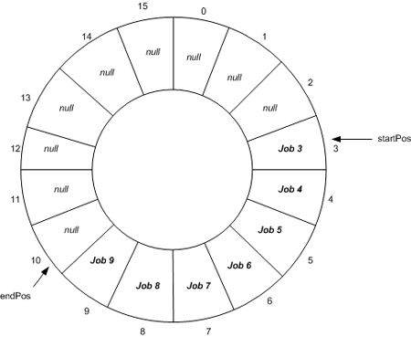
how to implement queue using single linked list?

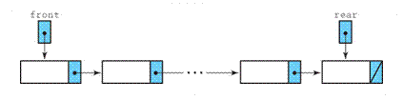

Push at rear.
Pop at front. Pop at Rear cannot be done. Because rear node doesn’t have anyone to point or because it is single linked list. But if we remove at front we can move the pointer to next node.

